**Use Wireshark to capture DHCP Discover, Offer, Request, and Acknowledge messages and explain the process.**

I used ipconfig /release and ipconfig /renew to force my system to get a new IP address from the DHCP server.

ipconfig /release – My system temporarily has no IP assigned.

ipconfig /renew – This asks the DHCP server for a new IP.

It starts the DHCP process (Discover, Offer, Request, Acknowledge).

**DORA Process:**

The DORA process is how a device gets an IP address from a DHCP server.

1. **Discover (D)** – The device broadcasts a request asking for an IP.
2. **Offer (O)** – The DHCP server replies with an available IP.
3. **Request (R)** – The device asks the server to assign that IP.
4. **Acknowledge (A)** – The server confirms and gives the IP to the device.

**Ipconfig/release:**

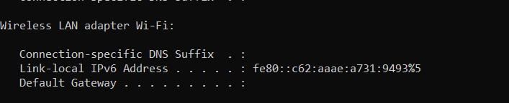

**Ipconfig/renew:**

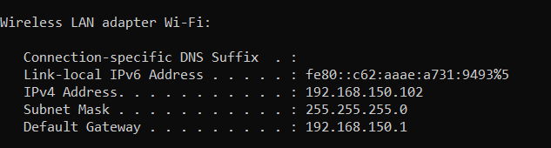

**Capturing DHCP:**

